**What is the OpenAI API?**

**WORKING WITH THE OPENAI API**

# James Chapman

Curriculum Manager, DataCamp

**Coming up...**

# Course goals

Use the OpenAI API to access AI models

Use those models to solve various tasks Use **Python** code to do this!

# Expected knowledge

Subsetting Python lists and **dictionaries**

Control flow → if , elif , else

Loops → for , while

# Not expected to know

AI or machine learning

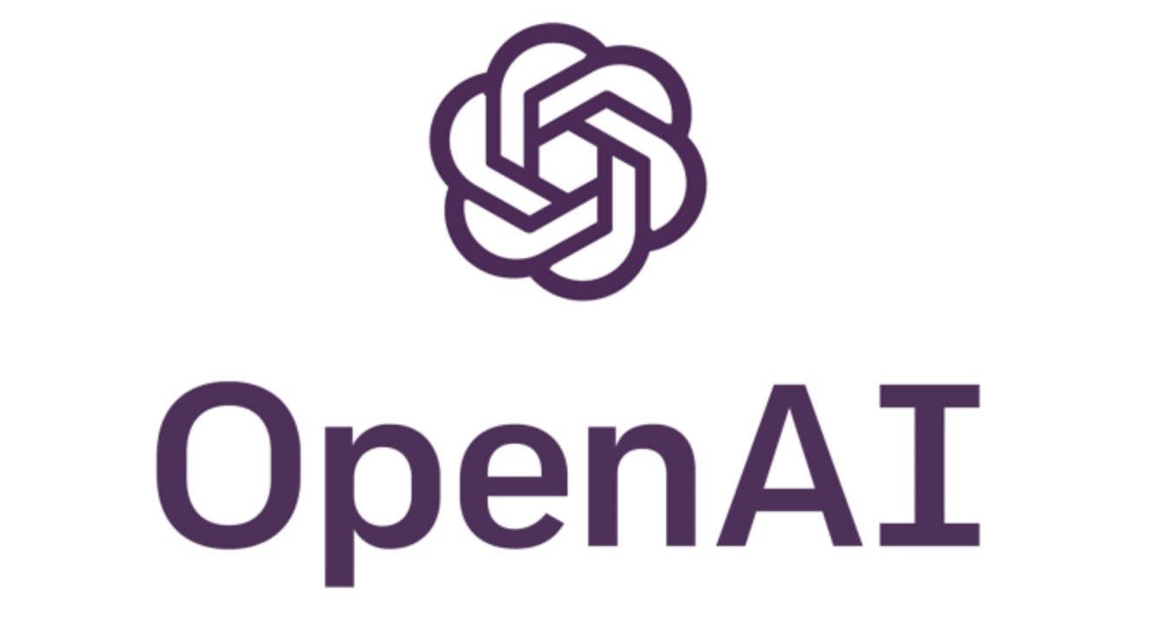 **OpenAI** = AI R&D company

**ChatGPT** = AI application

**OpenAI API** = Interface for accessing

OpenAI models

1 Image Credit: OpenAI

**OpenAI** = AI R&D company

**ChatGPT** = AI application

**OpenAI API** = Interface for accessing

OpenAI models

**OpenAI** = AI R&D company

**ChatGPT** = AI application

**OpenAI API** = Interface for accessing

OpenAI models

**A**pplication **P**rogramming **I**nterface

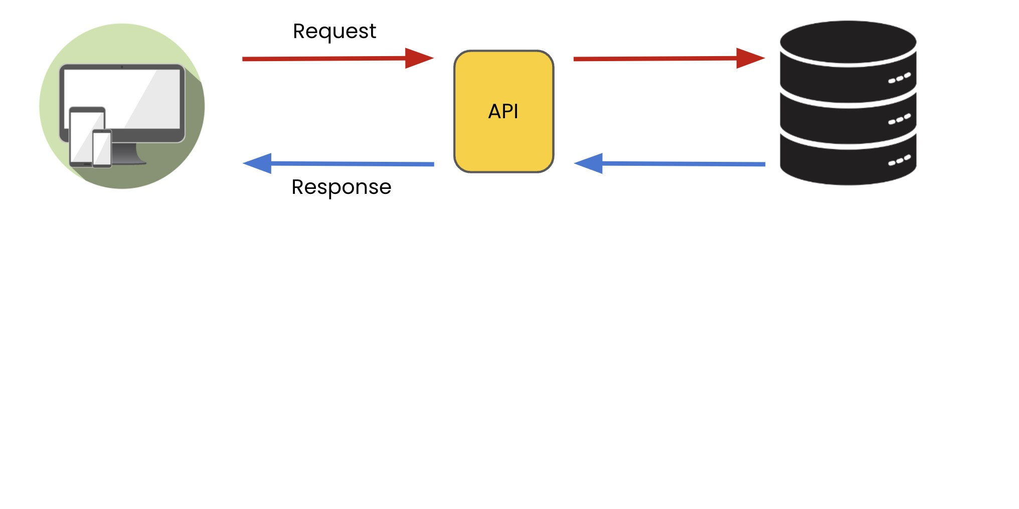

**A**pplication **P**rogramming **I**nterface

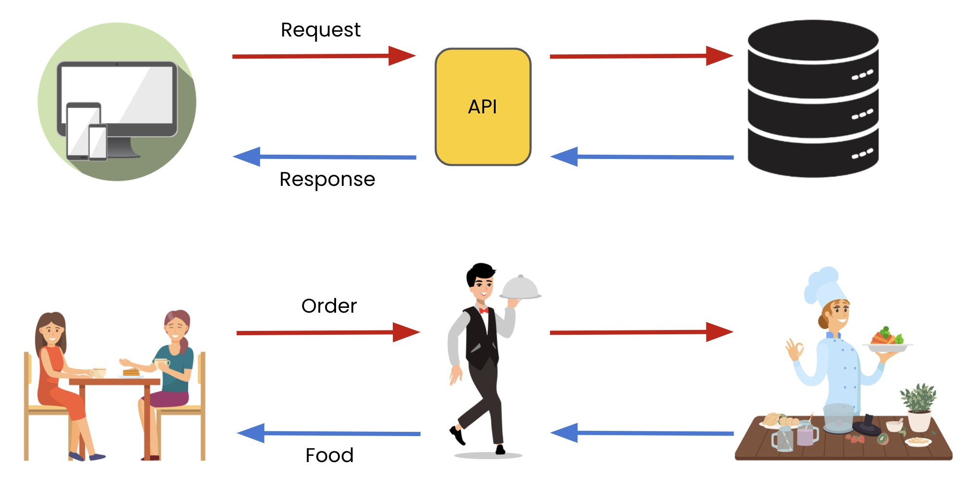

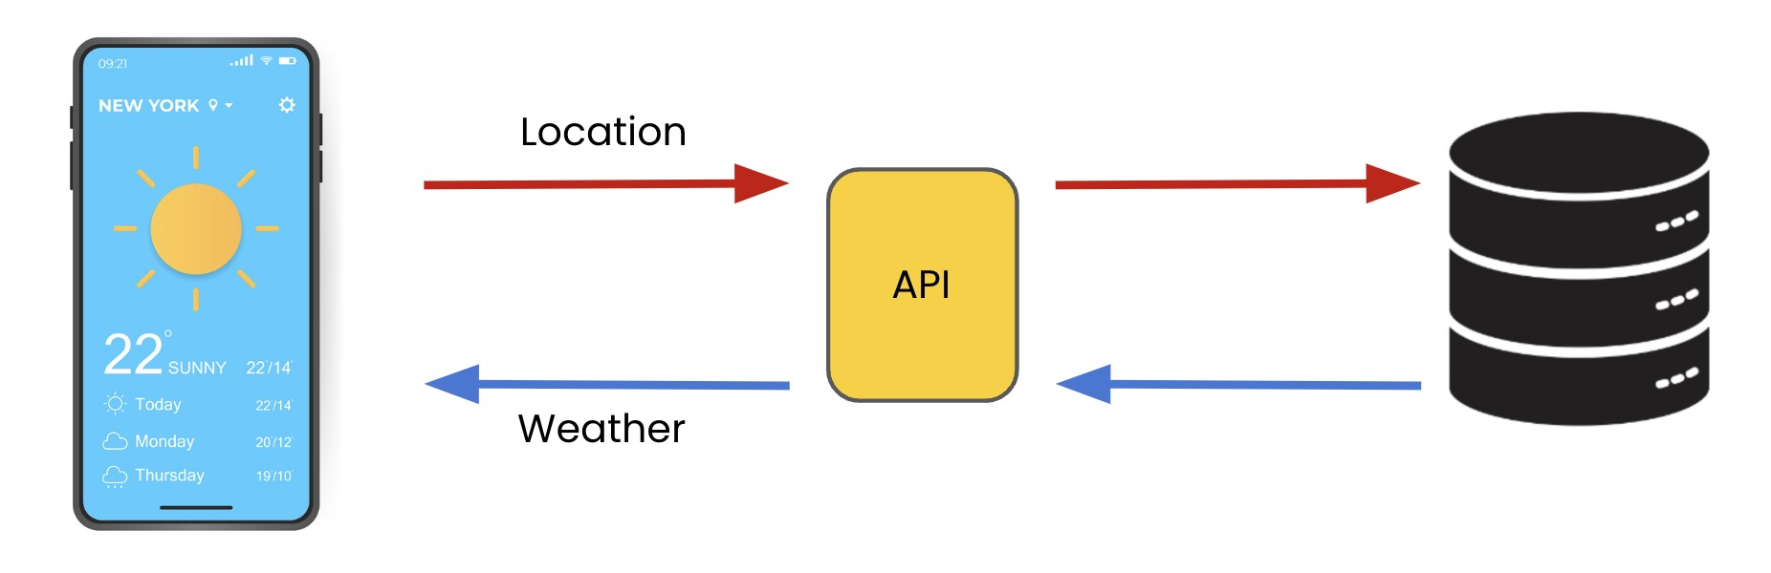

# The OpenAI API

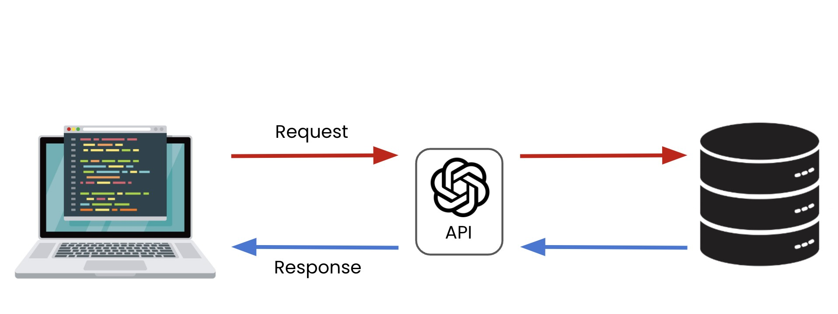

# The OpenAI API

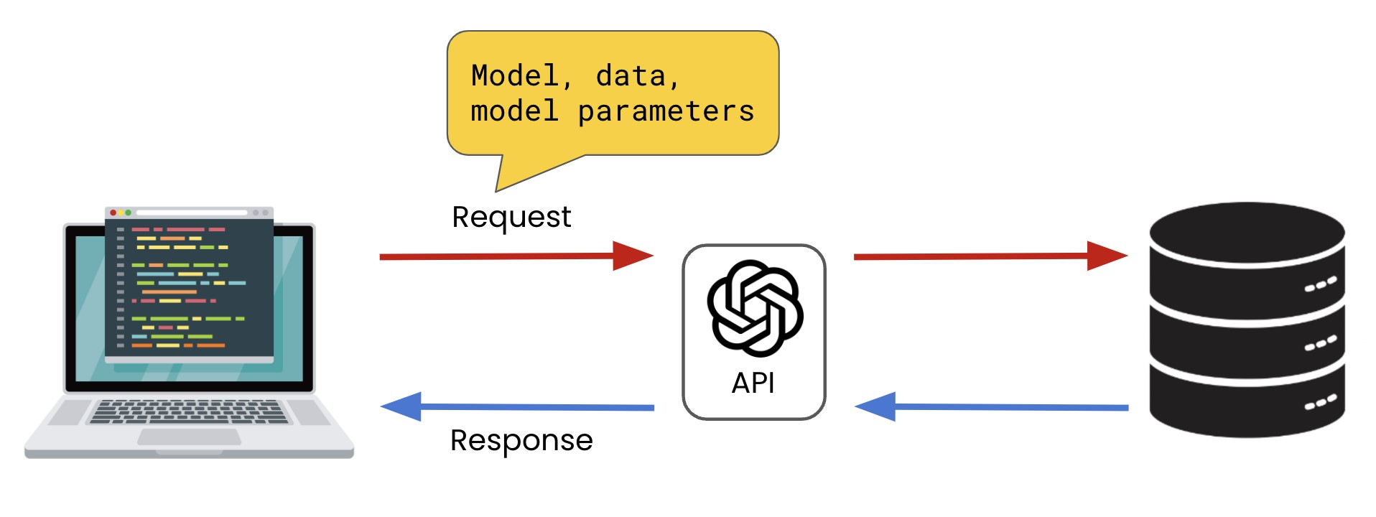

# API vs. web interface

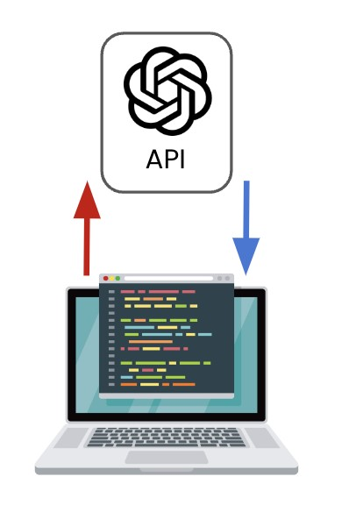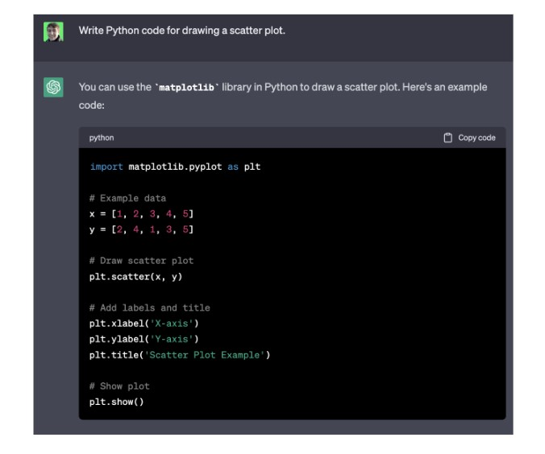 Provides flexibility for integrating AI into products, experiences, and processes Interact via programming language

Very little setup

Sufficient for streamlining individual's workflows

# Building AI applications

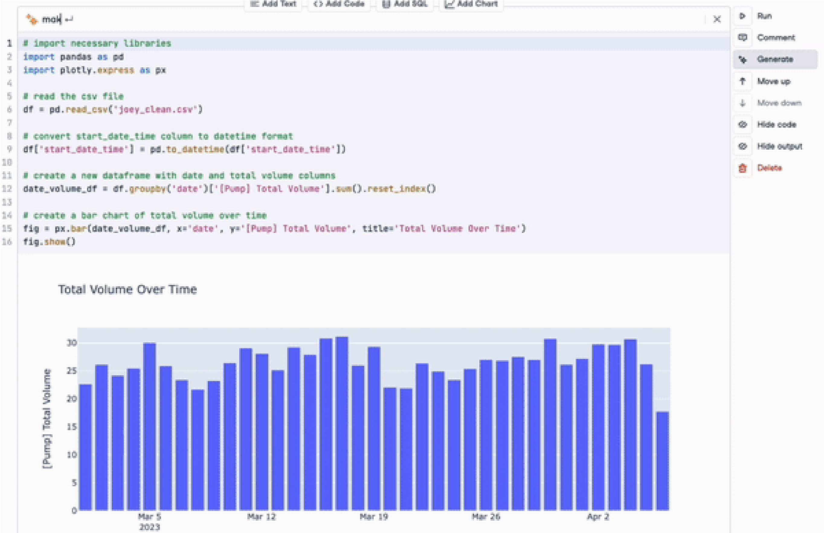**DataLab** = Cloud-based, AI-powered IDE

1 https://www.datacamp.com/datalab

**Let's practice!**

**WORKING WITH THE OPENAI API**

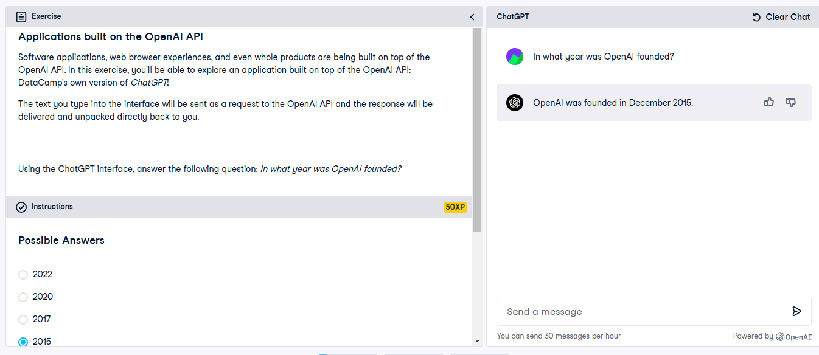

**client.chat.completions.create()** is part of the **OpenAI Python package** (openai).

The create() method is defined within the **Completions class** in OpenAI’s API client.

**How does it work?**

When you install the openai package (pip install openai) and set up the client, it interacts with OpenAI's API.

**client.chat.completions.create()** is a high-level wrapper that sends a request to OpenAI's chat completion API.

Internally, it calls an HTTP API endpoint (POST <https://api.openai.com/v1/chat/completions>).

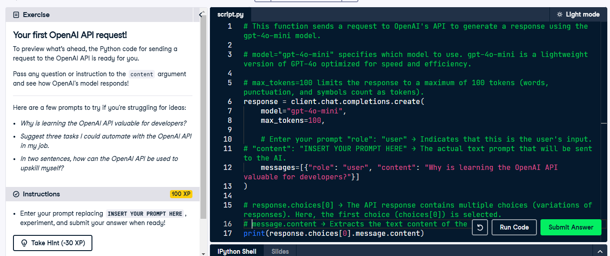

**Making requests to the OpenAI API**

**WORKING WITH THE OPENAI API**

## James Chapman

Curriculum Manager, DataCamp

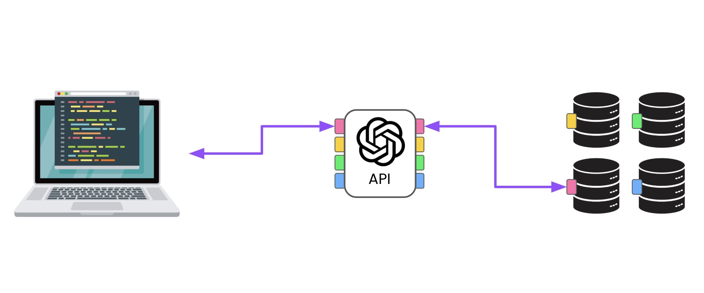

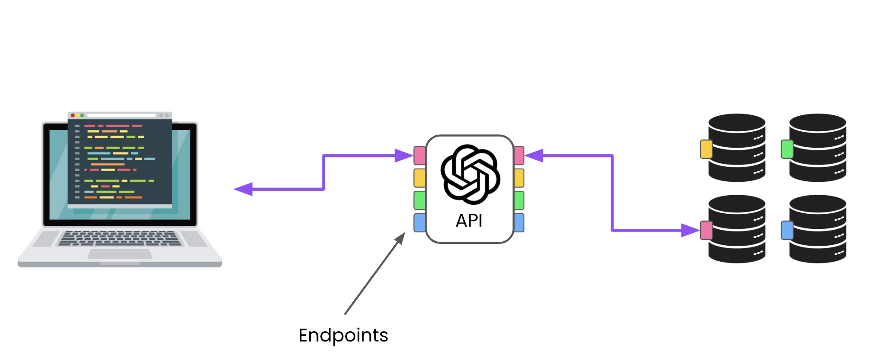

**Endpoints** → API access point designed for specific interactions



# API authentication

**Authentication** → Controls on access to API endpoint services (often unique **key**)



# API usage costs



For OpenAI API:

Model

Larger inputs + outputs = Greater cost

**No additional costs for this course**

1 https://openai.com/pricing

# Creating an API key

**Isn't required in this course**

1. Create your account → [**https://platform.openai.com/signup**](https://platform.openai.com/signup%7B%7B2%7D%7D)
2. Go to the API keys page → [**https://platform.openai.com/account/api-keys**](https://platform.openai.com/account/api-keys)
3. Create a new secret key and **copy it**

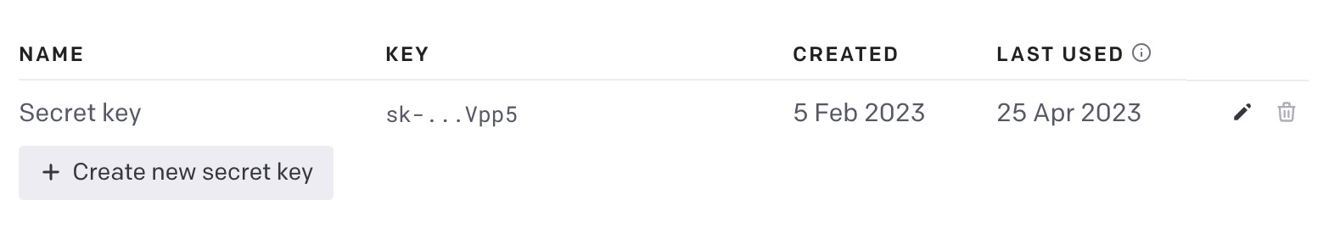

# Making a request

from

openai

~~i~~

mport

OpenAI

client = OpenAI(api_key=

"ENTER YOUR KEY HERE"

)

response = client.chat.completions.create(

model=

"gpt-4o-mini"

,

messages=[{

"role"

:

"user"

,

"content"

:

"What is the OpenAI API?"

}]

)

print

(

response

)

# The response

ChatCompletion(id='chatcmpl-AEcQbQekIzxcxVAKYVAjgUAXokgrl', choices=[Choice(finish_reason='length', index=0, logprobs=None, message=ChatCompletionMessage(content='The OpenAI API is a cloud-based service provided by OpenAI that allows developers to integrate advanced AI models into their applications.', refusal=None, role='assistant', function_call=None, tool_calls=None))], created=1728047673, model='gpt-4o-mini-2024-07-18', object='chat.completion', service_tier=None, system_fingerprint='fp_f85bea6784', usage=CompletionUsage(completion_tokens=30, prompt_tokens=14, total_tokens=44, prompt_tokens_details={'cached_tokens': 0}, completion_tokens_details={'reasoning_tokens': 0}))

# The response

ChatCompletion(id='chatcmpl-AEcQbQekIzxcxVAKYVAjgUAXokgrl', choices=[Choice(finish_reason='length', index=0, logprobs=None, message=ChatCompletionMessage(content='The OpenAI API is a cloud-based service provided by OpenAI that allows developers to integrate advanced AI models into their applications.', refusal=None, role='assistant', function_call=None, tool_calls=None))], created=1728047673, model='gpt-4o-mini-2024-07-18', object='chat.completion', service_tier=None, system_fingerprint='fp_f85bea6784', usage=CompletionUsage(completion_tokens=25, prompt_tokens=14, total_tokens=39, prompt_tokens_details={'cached_tokens': 0}, completion_tokens_details={'reasoning_tokens': 0}))

[Choice(finish_reason='length', index=0, logprobs=None,

message=ChatCompletionMessage(content='The OpenAI API is a cloud-based service provided by OpenAI that allows developers to integrate advanced AI models into their applications.', refusal=None, role='assistant', function_call=None, tool_calls=None))]

print

(

response.choices

)

Choice(finish_reason='length', index=0, logprobs=None,

message=ChatCompletionMessage(content='The OpenAI API is a cloud-based service provided by OpenAI that allows developers to integrate advanced AI models into their applications.', refusal=None, role='assistant', function_call=None, tool_calls=None))

print

(

response.choices

[

0

])

ChatCompletionMessage(content='The OpenAI API is a cloud-based service provided by OpenAI that allows developers to integrate advanced AI models into their applications.', refusal=None, role='assistant', function_call=None, tool_calls=None)

print

(

response.choices

[

0

]

.message

)

print

(

response.choices

[

0

]

.message.content

)

The OpenAI API is a cloud-based service provided by OpenAI that allows developers to integrate advanced AI models into their applications.

**Let's practice!**

**WORKING WITH THE OPENAI API**



